文華國民小學105學年度第二學期三年級英語科第一次成績考查閱讀試卷

年 班 座號： 姓名：

1. **Read and Circle (8%)**

**圈出對應的單字圖片**

* 1. a robot

FM2習作-P10-2FM2課本-P90-5

* 1. FM2課本-P91-2**FM2習作-P6-1** hot
  2. FM2課本-P90-2 a doll

FM2課本-P90-4

* 1. a ball

FM2習作-P9-5FM2課本-P90-3

1. **Look and Choose (10%)**

**讀一讀，選出正確的句子**

(　　) 1. A: Is this a ball? B: __________

(A) Yes, I am.

(B) No, it's not.

(　　) 2. A: __________ B: Yes, I am.

(A) Are you tired?

(B) How are you?

(　　) 3. A: Time for dinner. B: ______!

(A) Listen!

(B) OK!

(　　)4. A: Is that a kite? B: No, it's not. It’s a ______.

1. robot
2. sorry

(　　)5. A: Are you hot? B: ______.

1. No, it is.
2. No, I'm not.

**C.Read and Choose (6%)**

**填寫正確的句子代號**

a. Is that a robot? b Are you ready?

c. Good job! d Watch out!

e Is that a kite? f Is this a ball?

**FM2課本-P15-1**1.

**…**

2.

**FM2課本-P29-2**

**…**

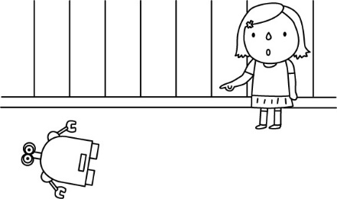

3.

**FM2習作-P9-2**4.

**FM2課本-P13-5**

5.

**FM2課本-P15-2**

**…**

6.

**D.Read and Choose (8%)**

|  |  |
| --- | --- |
| **讀一讀，選出正確的答案**  (Jack and Kevin are in a school.) | |
| Kevin: | Look! 　(1)　that a yo-yo? |
| Jack: | No, it's not. |
| Kevin: | (2)　 is that? |
| Jack: | (3)　 a kite. |
| Kevin: | What's this? Is 　(4)　 a doll? |
| Jack: | No, it's not. |
| Kevin: | Wow! It can sing. 　(5)　 this? |
| Jack: | (6)　 a robot. |
| Kevin: | Time for dinner.  Are you 　(7)　? |
| Kevin: | Yes, I 　(8)　. |
| Jack: | Let's go! |

＊and和、in在、school學校can會、sing唱歌

1. (　　) (A) Is (B) Are

2. (　　) (A) What (B) This

3. (　　) (A) This (B) It’s

4. (　　) (A) you (B) this

5. (　　) (A) What's (B) How's

6. (　　) (A) It's (B) There

7. (　　) (A) hot (B)hungry

8. (　　) (A) am (B) is

**E.Look and Match (6%) 用尺連連看**

**hungry**

**飢餓的**

**口渴的**

**F. Look and Copy (6%)寫**

**kite**

**not**

**yo-yo**

**thirsty**

**tired**

**風箏**

**溜溜球**

**不是**

**疲累的**