ㄅ

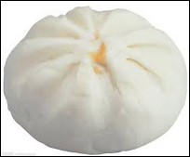

ㄆ



ㄇ



ㄈ



ㄓ

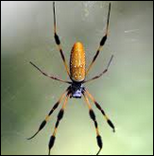

ㄔ



ㄕ



ㄖ

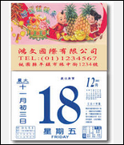

ㄐ

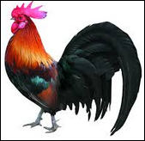

ㄑ



ㄒ

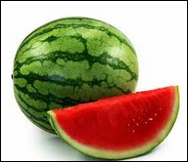

ㄍ



ㄎ

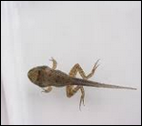

ㄏ



ㄉ

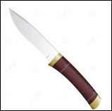

ㄊ

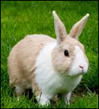

ㄋ

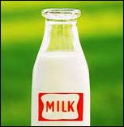

ㄌ

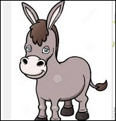

ㄦ



ㄗ

[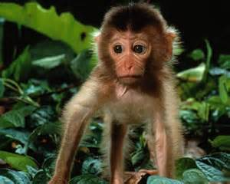](http://www.bing.com/images/search?q=monkey&view=detailv2&&&id=A480FCDB909A167BE9ACF27F3C4283824DA6D034&selectedIndex=2&ccid=7jv1iweo&simid=607996215218866033&thid=JN.YpUkidtbdlQDtcoyQy1QbA)

ㄘ

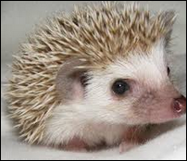

ㄙ

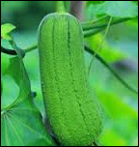

ㄢ

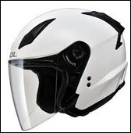

ㄣ

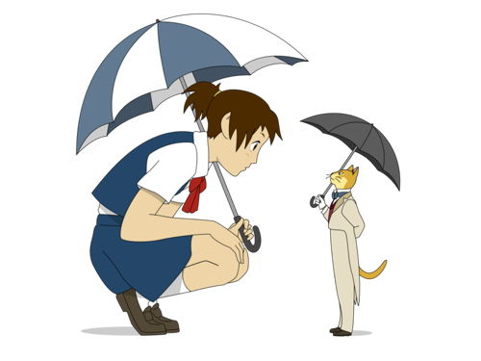

ㄤ



ㄥ



ㄞ



ㄟ

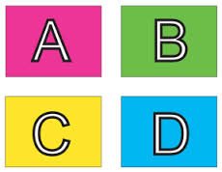

ㄠ

[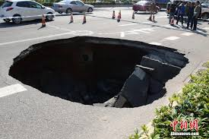](http://www.google.com.tw/imgres?imgurl=http://www.sinaimg.cn/dy/slidenews/1_img/2015_03/2841_537586_309439.jpg&imgrefurl=http://slide.news.sina.com.cn/s/slide_1_2841_80394.html&h=626&w=940&tbnid=aUJo4kkkEYNYBM:&zoom=1&docid=kMeiqtDO2-c4RM&hl=zh-TW&ei=keNCVb7YG-K_mwWb94DIBQ&tbm=isch&ved=0CC4QMygTMBM)

ㄡ



ㄚ



ㄛ

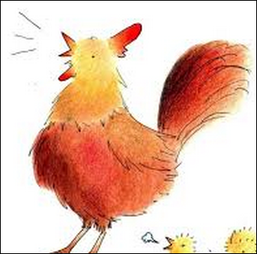

ㄜ

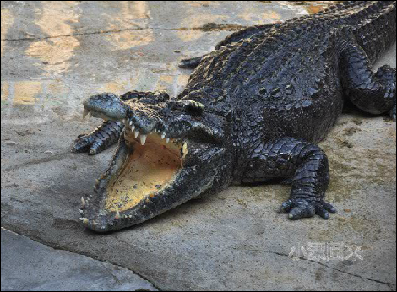

ㄝ

ㄧ



ㄨ

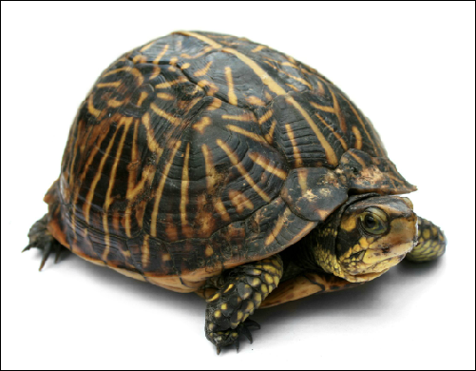

ㄩ

