注音符號-注音符號(all)
(ㄅ) | [包子ㄅ] | 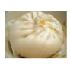
(ㄆ) | [葡萄ㄆ] | 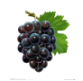
(ㄇ) | [帽子ㄇ] | 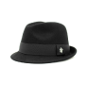
(ㄈ) | [飛機ㄈ] | 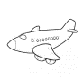
(ㄉ) | [刀子ㄉ] | 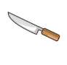
(ㄊ) | [兔子ㄊ] | 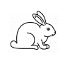
(ㄋ) | [牛奶ㄋ] | 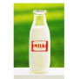
(ㄌ) | [驢子ㄌ] | 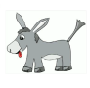
(ㄍ) | [鴿子的ㄍ] | 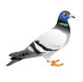
(ㄎ) | [蝌蚪的ㄎ] | 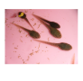
(ㄏ) | [喝水的ㄏ]
(ㄐ) | [公雞的ㄐ] | 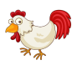
(ㄑ) | [油漆的ㄑ] | 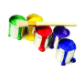
(ㄒ) | [西瓜的ㄒ] | 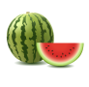
(ㄓ) | [蜘蛛的ㄓ] | 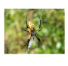
(ㄔ) | [吃飯的ㄔ]
(ㄕ) | [獅子的ㄕ] | 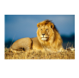
(ㄖ) | [日曆的ㄖ] | 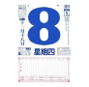
(ㄗ) | [ㄗㄗ叫的ㄗ] | 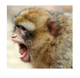
(ㄘ) | [刺蝟的ㄘ] | 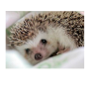
(ㄙ) | [絲瓜的ㄙ] | 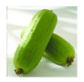
(ㄚ) | [ㄚㄚ叫的ㄚ] | 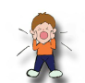
(ㄛ) | [ㄛㄛ叫的ㄛ] | 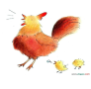
(ㄜ) | [鱷魚的ㄜ] | 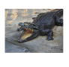
(ㄝ)
(ㄞ) | [愛心的ㄞ] | 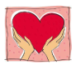
(ㄟ) | [ABCD的ㄟ] | 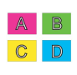
(ㄠ) | [凹洞的ㄠ] | 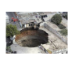
(ㄡ) | [海鷗的ㄡ] | 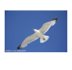
(ㄢ) | [安全帽的ㄢ] | 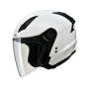
(ㄣ) | [報恩的ㄣ] | 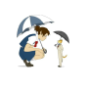
(ㄤ) | [骯髒的ㄤ] | 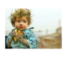
(ㄥ) | [ㄥㄥ的ㄥ] | 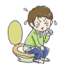
(ㄦ) | [兒童的ㄦ]
(ㄧ) | [醫生的ㄧ]
(ㄨ) | [烏龜的ㄨ] | 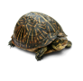
(ㄩ) | [瘀青的ㄩ] | 